Research Report: Cluster Genes (Liver) Analysis of Mice to Different Chemicals

Introduction:
Recently, we have been focused on identifying groups of highly correlated genes both with and without exposure to uncover their potential relationship. If these gene clusters are indeed interconnected, we are interested in building a dose-response model that can make analysis in toxicogenomic studies more computationally and statistically efficient.
To achieve this goal, we perform a series of analyses on a toxicogenomic database. First, we perform hierarchical clustering of genes based on expression levels at zero exposure to identify the inherent correlation structure. Next, we apply K-means clustering of genes based on change in expression after exposure, which allows us to capture changes in gene expression and classify genes according to response pattern. Finally, we use hierarchical clustering within each of the K-means clusters to look for smaller subgroups where genes have even more similar profiles. Collectively, these methods help us to access the grouping of genes and their potential relationships in response to chemical exposure.

Data Used:
This analysis uses gene expression data associated with phenotype data from rat liver samples from in the Open TG-Gates database, a toxicogenomic database open to the public for researchers to utilize research results of TGP and TGP2 and releases the data of 170 compounds.

Analysis:
There are three normalized datasets provided by Dr. Daniel Svoboda and Dr. Scott Auerbach: The first one is a flat table, keyed by animal ID and barcode (Affymetrix CEL filename), containing experimental attributes along with clinical chemistry, hematology, and body and organ weight measurements. The second file contains pathology results keyed by animal ID and organ. The third file provides Affymetrix differential gene expression data, with the "microarray" column linked to the "BARCODE" in the attributes file.

- Hierarchical clustering of genes based on expression levels under zero exposure.
  - Extract both expression and phenotypic data and subset to baseline samples (dose= 0 mg/kg).
  - Transpose the expression matrix, calculate the standard deviation for each gene and filter out genes with variance below the median.
  - Compute an absolute correlation matrix between the filtered genes, convert it to a distance matrix using 1 - abs(correlation).
  - Perform hierarchical clustering using the Ward.D2 method and visualize the results with a dendrogram and heatmap.

- K-means clustering of genes based on change in expression following exposure.
  - Calculate the mean expression for control samples (does = 0 mm/kg) by grouping 'vehicle', 'time', 'tissue', 'route', 'sex', 'hybridization date' and 'strain'.
  - Calculate the mean expression for exposed samples (does ≠ 0 mm/kg) for each compound by grouping the same variables as above plus “compound”.
  - Calculate the difference in mean expression between control and exposed samples by grouping the same variables as in step 1.
  - Filter out the genes with a variance lower than the median variance across genes.
  - Use the Elbow method to find the optimal number of clusters.
  - Perform K means clustering of genes based on changes in expression after exposure.

- Hierarchical clustering within each of the K-means clusters.
  - Assign genes for each K-means cluster.
  - Calculate the Pearson correlation matrix for these genes and convert it to a distance matrix using 1 - abs(correlation).
  - Perform hierarchical clustering using the Ward.D2 method on the distance matrix.
  - Create a heatmap of the correlation matrix ordered by the hierarchical clustering.

Result:
- Hierarchical clustering of genes based on expression levels under zero exposure

Figure 1: Cluster Dendrogram among Genes with High Variance
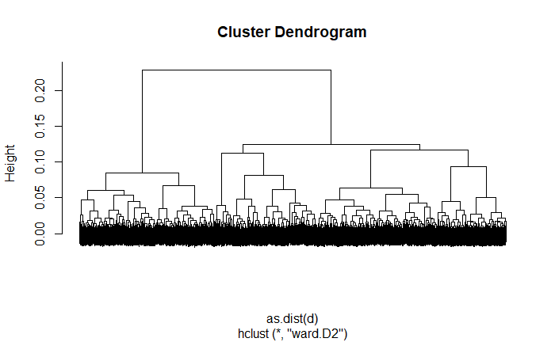
Figue 2: Heatmap among Genes with High Variance
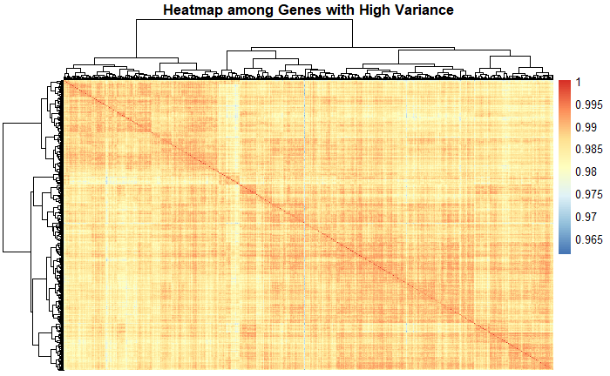
- K-means clustering of genes based on change in expression following exposure.
Figure 1: The Elbow Method Showing the Optimal Number of Clusters
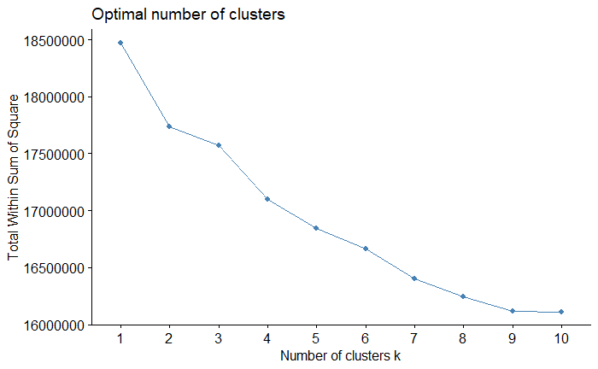
The elbow method group above shows that there is an "elbow" or bend at k = 2 or 3 clusters, this is the point where the sum within the sum of squares begins to level off.

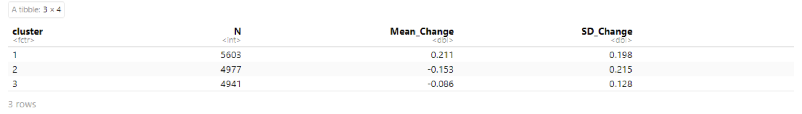
K-means clustering on the dataset, with k = 3 initiating 25 random starts to ensure stable clustering results. The output includes cluster assignments for each gene: K-means clustering with 3 clusters of size 5603, 4977 and 4941.

- Hierarchical clustering within each of the K-means clusters
Figure 1: Heatmap for K-means Cluster 1 with Size of 5603
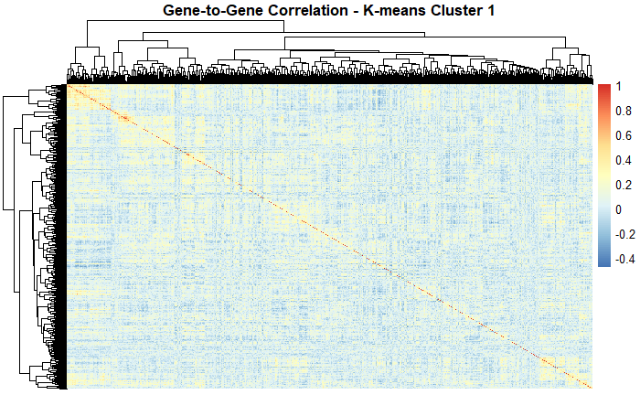
Figure 2: Heatmap for K-means Cluster 2 with Size of 4941

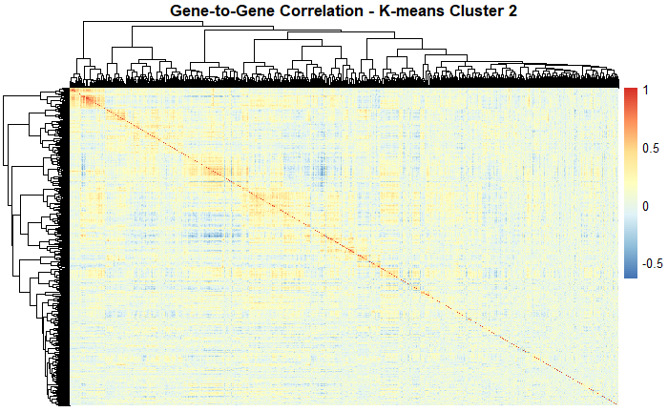
Figure 3: Heatmap for K-means Cluster 3 with Size of 7268
